Moore’s Law: 18 mouths, transistors in a chip(芯片) doubles
Clock Speed: pulse frequency by clock(synchronized pulse)
CPI (Cycles per instruction): 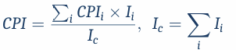
$I_{i}$: Each instruction’s proportion of program
: The number of cycles of each instruction
MIPS (Million Instruction per Second):$MIPS=\frac{f}{CPI×{10}^{6}}$
MFLOPS (Million Floating point Operations per Second)
We better actually measure the time of doing real jobs:
SPEC marks (Standard Performance Evaluation Corporation)
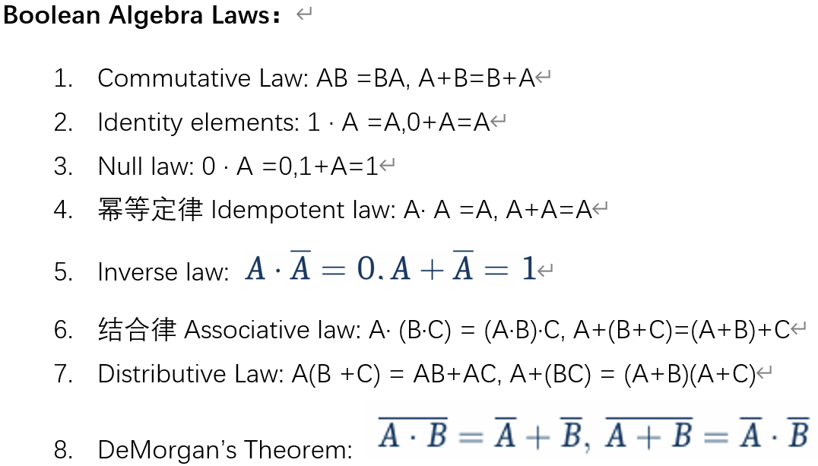
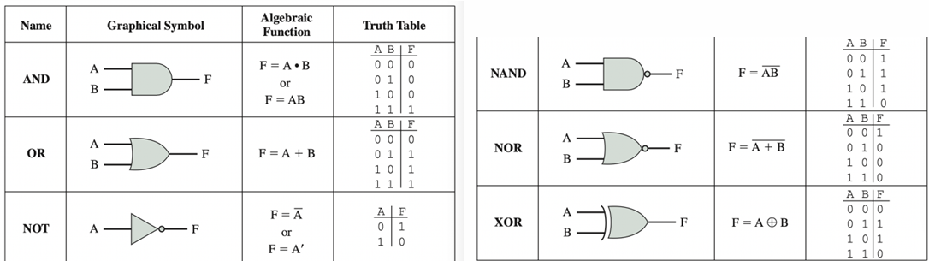
Functional completeness: We can only use NAND/NOR to express all operations.
SOP (Sum of products) / POS (Product of sums)
Half Adder: $Sum=A⊕B;Carry=A\bigwedge{B}$
Full Adder: $Sum=A⊕B⊕Cin;Cout=\left(A∧B\right)∨\left(Cin∧\left(A⊕B\right)\right)$
Finite Precision Number: The size and number of possible representations is fixed
Radix (基数) Number Systems: ${\left(…{a_{2}a}_{1}a_{0}a_{-1}a_{-2}…\right)}_{r}=\sum_{i}{a_{i}r^{i}}$
Faster way to calculate value of radix number system:
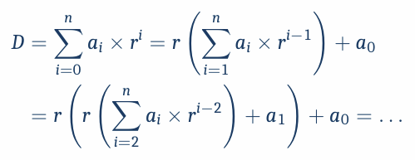
Excess K (offset binary/excess code/biased representation):
We usually use $K=2^{n-1}$
One’s complement: For -, invert all bits, $value=2^{n}-f-1$
Two’s complement: For -, invert all bits then add 1, $value=2^{n}-f$
Range Expand: For -, add 1 before original bits.
Floating-point representation:
$$Value=±{\left(1\left(or0\right).xxxxxxx\right)}_{2}×2^{Exponent}$$
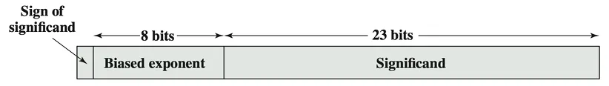
Sign bit: 1=”-“; Exponent: Excess $2^{m-1}-1$; Significand: xxxxxx
Expressible Numbers: we assume m-bit exponent, n-bit significand:
$2^{1-2^{m-1}}≤\left|range\right|≤\left(2-2^{n}\right)×2^{2^{m-1}}$(不考虑IEEE特殊情况)
Multiplication of 2’s complement: 若乘数为负, 则乘数每个1与被乘数相乘的结果按负数range expand(添1), 求和即为结果的补码表示
Floating-point Addition/subtraction:
1 Check for zeros 2 Align the significand 3 Add (Subtract) the significand
4 Normalize(right/left shift) 5 Rounding
Floating-point Multiplication: ($exp_{i}$均为bit pattern)
$$\left(±\right)m_{1}×2^{exp_{1}}×\left(±\right)m_{2}×2^{exp_{2}}=\left(±\right)m_{1}×m_{2}×2^{exp_{1}+exp_{2}}$$
Bit pattern: $e_{result}=exp_{1}+exp_{2}-K$
Floating-point Division:
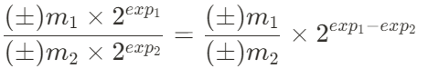
Bit pattern: $e_{result}=exp_{1}-exp_{2}+K$
Von Neumann architecture:
Instruction data stored in a single read-write memory; Contents of memory addressed by location; Execution occurs in sequential fashions.
Word: unit of organization (memory), smallest unit to process at once.
PC-Program Counter: Holds the next instruction(address)
IR-Instruction Register: Contains the current instruction.
MAR-Memory Address Register
MBR-Memory Buffer Register (aka Memory Data Register, MDR):
Contains the data returned from external memory||the data to be written to external memory, as bridge between CPU and external memory.
I/O A(B)R-I/O Address (Buffer) Register
IAC: Instruction Address Calculation (use PC, PC+=4)
Instruction Fetch: Fetch instruction from Memory
PC —> MAR, mem[MAR] —>IR
Instruction Execute: Execute the fetched instruction
Register and cache-fast, but small and expansive
Main memory, External memory- large and cheap, but slow
Go down the memory hierarchy: Cheaper, larger, slower; less frequency.
Principle of locality: 相邻/最近被引用的memory更容易被下次调用
Big Endian Mode: 0X2345678->12 34 56 78
Little Endian Mode: 0X2345678->78 56 34 12
CPU used to read memory word by word, but now it uses cache.
Access Method: Sequential Access, Random Access and their associate.
RAM (Random access memory): 传统RAM是volatile, 不供电会损失数据
SRAM (static RAM):用logic gate存储数据, 快, 无需刷新, 用于缓存内存
DRAM (Dynamic RAM): 用transistor, 慢, 需刷新, 用于主存, 便宜
ROM (Read-only memory): 数据不volatile, 用于存储start-up program
PROM (programmable ROM): 只能被写入一次(以电子方法)
Read-mostly memory: (以下三种)
Erasable PROM:强紫外线(intense ultraviolet)擦除; Electrically EPROM:电
flash: 介于前两者之间, non-volatile, 快, 写入前成块擦除, 成本低
Memory Performance: Access time(一次R/W操作的时间), Memory cycle time(前者+传输时间), Transfer rate
Burst Mode: 当数据被访问时, 相邻数据更快被传输
数据传输中可能错误(voltage spikes, electromagnetic interference, 电源)
使用单个奇偶校验位(Single Parity Bit)汉明码(Hamming Code)
Address Mapping: 
块尺寸为b, 则$Addr\%b$为块内编号, $Addr//b$为块编号->三种映射方式
Direct-Map: 1cache line固定对应一部分block, 简单快速便宜, 但易发生冲突(造成命中率下降)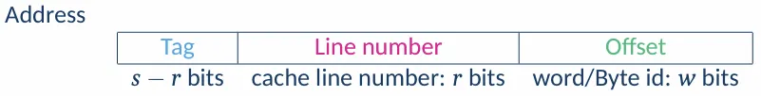
tag-对应的内存块标签; index-缓存行编号, 对行总数取模; offset
Fully associative: tag+word, block number=Tag
每次访问数据须比对所有缓存行, 慢但是冲突少
K-way set associative(上述两方法的结合):将缓存分为多个set, 每个set有k行, 按直接映射匹配set编号, set内按全相联映射.
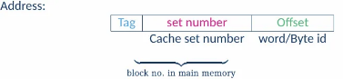
结合了上述两方式的优点
Replacement Algorithm:
FIFO-简单, 慢; LRU-复杂, 命中率高; RR(Random replace)简单, 不稳定
Write Strategy (为保持cache与memory数据一致性):
Write through: 当写入cache时同时写入主存, 慢,但数据安全
Write back: 当cache中数据被移除时, 写回主存, 快, 但不易I/O
多重缓存:
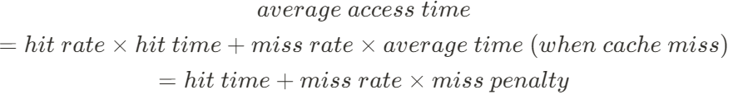
Miss penalty: extra time when cache miss occurs
Split caches: 缓存指令与缓存数据物理上分开且固定大小, 冲突少/灵活
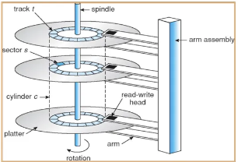
Unified Caches: 复杂但是灵活

Each sector:
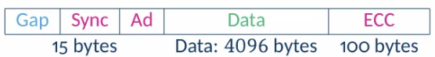
Gap: separates sectors; Sync: indicate后为信息域& timing alignment
Ad(Address Mark地址标记) ECC(Error Correction Code, 错误校正码)
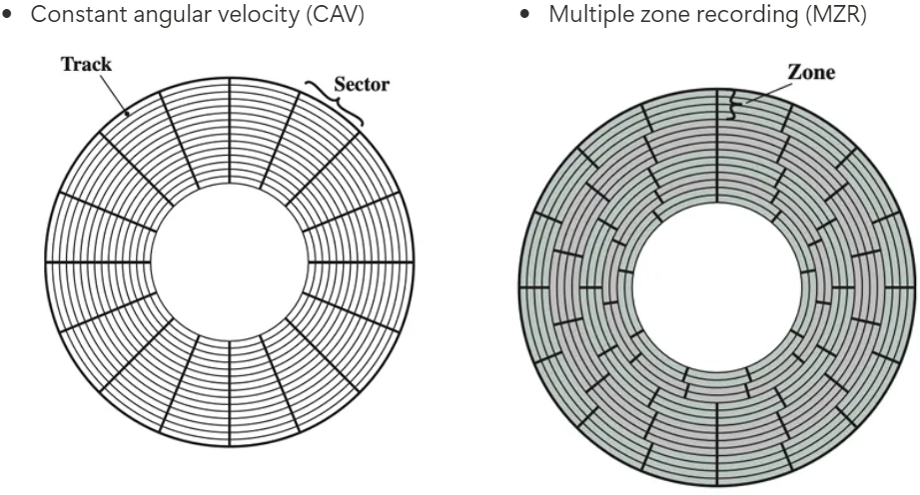
Disk access time: $Seek+Rotational delay+Data Transfer$
Transfer time: $t_{T}=\frac{b}{N}×\frac{1}{r}$, b: 传输字节数; N: 磁盘字节数; r: 每秒旋转圈数
Solid State Drives(SSD): Semiconductor, Flash Memory, 高IO性能, Durability耐用(no mechanical wear), 便宜, 快
RAID: Redundant Array of Independent (Inexpensive) Disks, 独立磁盘冗余阵列, 将多个物理硬盘驱动器组合成一个逻辑硬盘. 通过条带化(Striping)
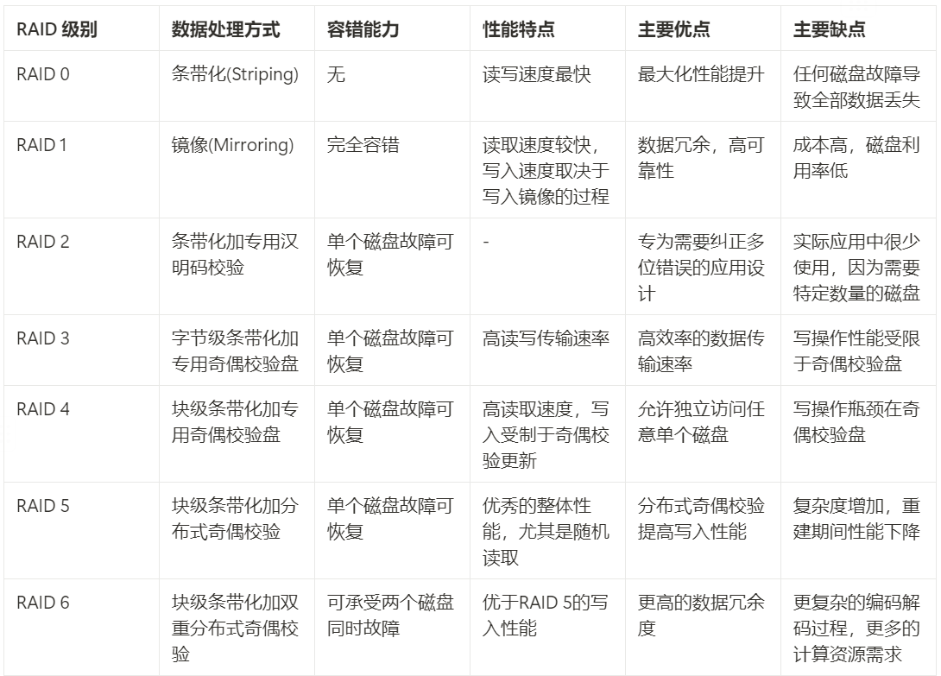
恢复磁盘故障: 校验盘P的每位=所有盘的对应位异或和
asynchronous communication(异步通信)
I/O Module: Interface to the processor and memory. Need Control, Timing, Processor/Device Communication, Data buffering
External Devices: Human readable and Machine readable.
Programmed I/O: 处理器直接控制I/O，但在等待时会浪费CPU周期
Interrupt-driven I/O: 处理器发出I/O命令后继续执行其他进程，当I/O完成时，I/O模块会中断CPU，CPU暂停当前程序处理中断。
Interrupt Processing:
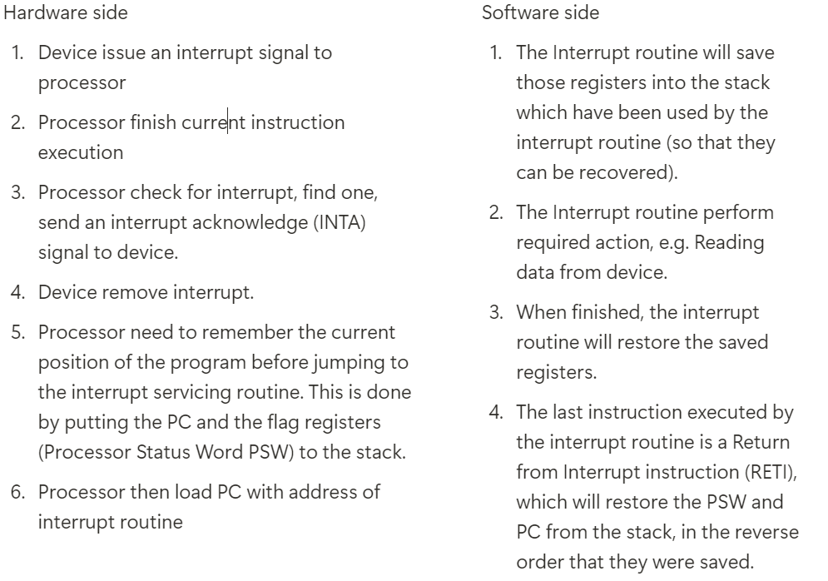
DMA (Direct Memory Access):
IOP (Input-Output Processor): steal cycles from CPU:
IOP issues signal给CPU使其与buses断连, 并elongate clock
Procedure/Function: self-contained程序, economy&modularity.
返回的地址储存在top of system stack, LIFO
General/Dedicated purpose registers:通用/专用 寄存器
PSW (processor status word) or flag register: 用于条件判断
有两种数据储存: Numeric: 整数或浮点数;
Non-numeric: (character)ASCII or Unicode/Binary data (bit-map)
Addressing methods:符号约定:
A-地址字段内容;R-寄存器;EA-effective地址;(X)-位置X的内容
立即寻址Immediate Addressing: $op=A$ Literal mode(小立即数);
Immediate Operand in the Next Word-对于大立即数
Direct Addressing (Absolute Addressing)$EA=A$
Indirect Addressing: $EA=(A)$
Register Addressing: $EA=R$
Register Indirect Addressing: $EA=(R)$
Displacement Addressing: $EA=A+\left(R\right)$
Stack Addressing: $EA=top of stack$
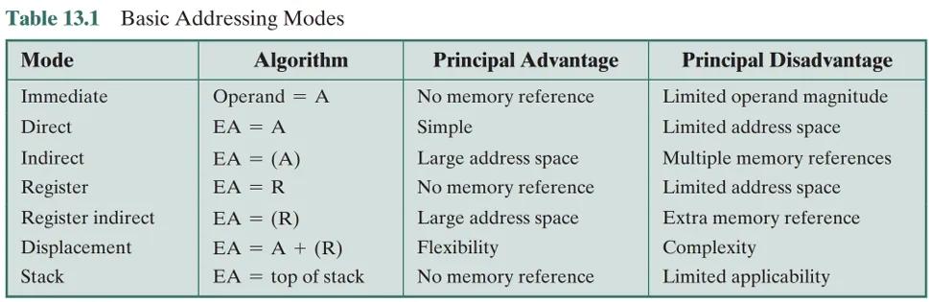
Assembly Language Programming:
Each lines has 4 fields: [label] mnemonic operand list comment
#114-立即数; [1234]-内存地址; R1(4)-偏移量;
OS提供的服务: Program Creation, Execution, IO Access, File System Management, System Access, Error detection and response.
Protection Scheme: user mode/Kernel(Supervisor) mode
Multi-tasking and Time-sharing System: 每个进程(process)被分配固定的time slice, 每用完一个slice会切换, 若在执行IO会主动释放CPU
Virtual memory: Physical地址: 用于实际访问内存的地址;
Logical地址: 程序使用的地址空间, 不一定对应物理内存的地址
MMU (Memory Management Unit):基于局部性原理工作，并通过地址映射将程序的逻辑地址转换为物理内存地址.
Page: 逻辑物理地址空间被划分为fix size页面, 每进程有自己的逻辑地址空\\PTE (Page Table Entries):V- Valid bit, page是否在内存中;
P- Protection information(权限); D-Dirty bit, 页面是否已被修改
Demand Paging: 当程序启动时, 内存空, 读数据才加载page.
Fast response, 但是会大量page faults, 使用prepaging解决缺点
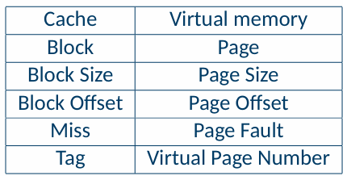
Address Translation: 程序通过CPU bus内存，提取logical page number，查找对应PTE-若页面在内存，则获取physical frame number并附加页内偏移量；若不在，则生成一个page fault, 通过IO从hard disk
Page Fault处理: 从硬盘加载page, 在物理内存中找到空闲页面，无则择一替换(replace,判断是否写回HD), 更新PTE
Page Replacement: FIFO or Least Recently Used (LRU)
Write Strategy: 通常采用Write back, 因为写入硬盘慢/成本高
TLB (Translation Lookaside Buffer): 每次虚拟内存引用可能导致两次物理内存访问: 获取PTE && 获取数据。使用buffer加速
结合缓存与虚拟内存: 获得物理地址后，使用该地址访问缓存内存，并根据情况处理缓存未命中问题。(在地址转换之后)确保高效的数据访问流程
Processor Organization: 处理器通过Data Movement与Data Processing / Transformation执行指令. 数据存储在register中, 用控制单元(Control Unit)生成的控制信号来协调操作.
Instruction Execution Cycle: FI (Fetch Instruction)-DI (Decode Instruction)-CO (Calculate Operand Address)-FO (Fetch Operands)-EI (Execute Instruction) -WO (Write Operand)
指令流水线 (Instruction Pipeline): 目标是提高吞吐量(Throughput)
现代RISC架构: FI, DI, EX(执行), MEM(访问内存), WB(写回)
理想的pipe:仍需要5stage, 但是平均一个cycle只需要1指令(CPI=1)
流水线冒险(Pipeline Hazards):
资源冲突(Resource/Structural Hazard)硬件资源被多个阶段同时请求解决
方案: 增加更多resource; separate data/instruction cache (split cache)
数据冒险(Data Hazard)当前指令依赖于前面指令的结果, 但尚未写回
类型：RAW(Read After Write, 最常见)WAR and WAW
方案: 优化指令顺序; 转发(Forwarding, ALU输出直接到下一个指令输入),
控制冒险(Control Hazard)条件分支指令导致无法确定下一条指令地址
方案: 静态预测(Static Prediction)：总是预测不跳转或跳转。
延迟槽(Delay Slot)：在分支指令后插入不影响判断结果的指令。
动态预测(Dynamic Prediction)：根据历史记录预测，准确率可达90%+。
simple branch prediction-预测错误就改变, 可能会导致frequently误判.
双错误阈值机制: two consecutive wrong prediction to change decision.
处理器性能公式与影响因素
$$Execution Time = Instruction Count × CPI × Clock Cycle Time$$
IC: 程序所需指令数量; CPI(Clocks)：每条指令平均所需时钟周期数。
Clock Cycle Time(T)：每个时钟周期的时间长度(即 1 / 主频)。
提升处理器性能的关键技术
1. 更有效的指令流水线(Pipelining)减少CPI，提高吞吐量(idea CPI=1)
2. 多执行单元(Multiple Execution Units)同时执行多条指令(提高 IPC)
3. 更大寄存器文件(Register File)减少内存访问次数 → 提高速度。
4. 精简指令集(RISC)简化指令格式 → 减少eliminates microprograms
Characteristics of Modern Processors: 1所有指令都是register-register type(除LOAD, STORE外); 2指令fixed长度与format,简单; 3少指令和寻址方式; 4hardwired替代microprogrammed control; 5使用instruction pipelining, extensive SW and HW techniques;
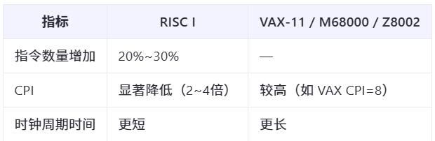
Characteristics of RISC: 同CMP1235+optimizing(优化) compiler

